Design and Implementation of a District Integrated Dashboard for Data-Driven Governance

Yanamala Jaswanth Reddy
Department of Computer Science and Engineering,
Presidency University Bengaluru, India
jaswanthyanamala@gmail.com

Purohith Satyanarayana
Department of Computer Science and Engineering
Presidency University Bengaluru, India
satyaguru70755@gmail.com

Amaregouda
Department of Computer Science and Engineering
Presidency University Bengaluru, India
amaregouda449@gmail.com

Ms. Poonam
Assistant Professor
School of Computer Science and Engineering
Presidency University Bengaluru, India

Abstract—In this paper, I come up with an integrated Dashboard for Bagalkot incorporating four main factors like Education, Health, Agriculture and Food Processing. The concept is to gather and keep all the important data in a single place and provide insights that map-based and at taluk level thus making it easier and faster for decision-makers to take decisions that are based on the proper information. The dashboard keeps track of enrolment, attendance, teacher absence and inspection remarks for the Education sectors. Officials can select by taluk, like Badami, Bagalkot, Mudhol etc…, and pinpoint schools that need immediate support. It provides Health Selector with OPD/IPD, bed occupancy, ambulance response on time and Essential medicines out of stock. For Agriculture, it became source of information for seasonal crops sown area, irrigation status, weather warnings and mandi prices, thereby assisting is planning inputs and advisories before and to avoid losses. In case of Food Processing, the dashboard tracks the amount of raw materials bought, mill/plant utilization, cold-chain availability and time taken from farm gate to processing so that bottlenecks can be resolved early. The dashboard is loaded with KPI’s, trendlines, and alerts for all four sectors, and it has a role-based access for the Collector and department teams. It wants to improve the routine reviews, emergency response and accountability in Bagalkot by replacing manual collation with automated, transparent views.

I. Introduction :
District administrations are increasingly dependent on timely, accurate information in order to plan interventions, distribute resources, and assess program outcomes; yet, information is generally scattered in departmental files and portals, so routine reviews are cumbersome and error-prone. The District Integrated Dashboard for Bagalkot fills this void by integrating multi-sector indicators—ranging from health to education, agriculture, and infrastructure—into a unified, student-developed web platform that serves district, taluk, and block-level decision-making. A lightweight ETL process normalises departmental CSV/Excel/API inputs via validation, deduplication, and referential checks to guarantee published KPIs
are consistent and auditable. By providing filterable dashboards, export‑ready reports, and role‑based access for viewers, analysts, and officers, the platform decreases effort on manual compilation, streamlines monthly reviews, and produces a shared evidence base for coordinated action. The modular structure also enables ease of rapid onboarding of new indicators and future developments, such as geospatial overlays and scheduled orchestration, providing a scalable template for transparent, outcome‑oriented governance in Bagalkot.

II. Literature Review :
1]District Integrated Dashboard for Mehsana (2024): Positions dashboards as tools of data and scheme management that make public information more easily accessible in one district at a time; the main limitation is geographic scale, with suggestions to generalise models and metadata for multi‑district replication and benchmarking.​​
2]Web-Based District Administration Dashboard (2023): Illustrates how interactive visualisation enhances administrators' analysis and interpretation but raises privacy issues; literature calls for incorporating role-based access control, data minimisation, and audit logging to reconcile transparency with regulation.
3]AI-Based Skill Gap Dashboard by UPSUM (2025): Applies machine learning to skill assessment in order to guide policy; issues of recurring nature are completeness and veracity of upstream data, implying strong ETL validation, imputation techniques, and explainable models for responsible recommendations.​
4]Spatial Dashboards for Kochi City (2025): Emphasises the importance of spatial visualisation in urban management and mentions data integration issues; research suggests geocode standardisation, use of authoritative boundary registries, and metadata catalogues as a way to harmonise non‑spatial datasets with maps.
5]Geospatial Dashboards for Smart Cities (2021): Reports map-based dashboards facilitate sustainable urban planning but are beset with data variability; ideal practice is to use schema registries, versioned APIs, and automated data quality checks in order to stabilise layers in the long term.
6]Data Integration Dashboard for Sustainable Farming: Demonstrates cross‑source integration facilitates planning but reveals scalability boundaries in processing and storage; literature suggests normalised relational centres with
pre‑aggregated views and incremental loading to manage seasonality and bulk.​​
7]Centralised Resource Management Dashboard (2025): Predictive, Shiny‑based design offers live crop recommendations but exposes scalability boundaries; shifting to service‑oriented backends with queued jobs and caching is suggested for high‑concurrency public systems.​​
8]Data Dashboards for School Administrators (2008): Early school dashboards enhanced governance but suffered from stale data; later works focus on scheduled ingestion, freshness metrics, and governance policies for routine maintenance and review cycles.​​
9]Public Health Digital Dashboards: Evidence shows dashboards facilitate data-driven decision-making but need wider stakeholder education and standardised indicator definitions to prevent misinterpretation; incorporation of computation formulas and confidence notes in UI is recommended.​​
10]Cross-cutting security takeaways: Throughout research, concerns regarding privacy and sensitive areas require RBAC, field-level access, and anonymisation when necessary, combined with explicit consent and retention policies to maintain confidence and compliance with law.​​
11]Synthesis for district application: The literature comes together in five doable design principles for a District Integrated Dashboard—validated ETL and metadata, MVC/layered web architecture with REST APIs, spatial preparedness with standardised geographies, role‑based security with audit trails, and exportable artefacts tuned to review workflows—to support adoption, scalability, and accountability in district governance settings.​​

III. Proposed Methodology :
A phased, MVC-inspired client–server model combines multi‑sector data sets into a secure, responsive district–taluk–block hierarchy‑aligned web dashboard with validated ETL, RESTful services, and exportable evidence for audits.​​

Phase 1: Requirements and KPI design
Stakeholder identification (admin, officer, analyst, viewer) and definition of role scopes and audit requirements.​Define KPI dictionary by sector (health, education, agriculture, infrastructure) with numerator/denominator, time window, and geography keys to ensure consistent computation.​​
Phase 2: Data ingestion and validation (ETL)
Source mapping of departmental CSV/Excel/API feeds; establish canonical schemas for district–taluk–block entities and ref tables.​Use validation: type casting, range checking, deduplication, referential integrity, and outlier flags; quarantine failed records with reason codes and reconcile logs.​Keep versioned staging and prod datasets to enable rollbacks and audits.​
Phase 3: Relational model and storage
Create MySQL 8.0 normalised schemas for domains, periods, geography, and facilities/schools; include period–geography query indexes and SQL views on aggregates used most often.​Seed with sample histories to ensure the correctness of joins and trends before live loads.​
Phase 4: Service layer (APIs)
You need to build API endpoints in Node.js, organized by sector. Include query parameters for things such as period, taluk, block and indicators. Make sure to handle input validation, set up CORS and create structured models for errors. Then add JWT for authentication along with middleware for role-based authorization. Also track all access events so audits can work properly. Finally, put in the assemblage handlers that cover trends, comparisons, and percent ranks. Use SQL views to keep performance solid
Phase 5: Presentation layer (UI)
Develop a responsive front-end using HTML5, CSS3 and JavaScript. Integrate Chart.js to handle time series charts and bar charts. Adds filters that let users select by sectors. Save user filters and the most recent KPI’s they viewed into local storage. This setup speeds up repeat analysis quite a bit.

Phase 6: Security, governance, and QA
Enforce RBAC policies, password hygiene, token expiration, and input sanitation; provide dataset lineage and KPI formula disclosure in the UI. Create data governance rhythms: ingestion schedules, freshness indicators, reconciliation procedures, and change management for KPI definitions.

Phase 7: Testing and deployment
Functionality: Cross-check KPIs with departmental overviews; Usability: heuristic testing for desktop and mobile; Performance: monitor P95 latency for overview, taluk comparisons, and 12‑month trends.​Deploy on a Linux server with process manager (for example, PM2), HTTPS termination, backups, and monitoring; write down SOPs for analysts and admins.

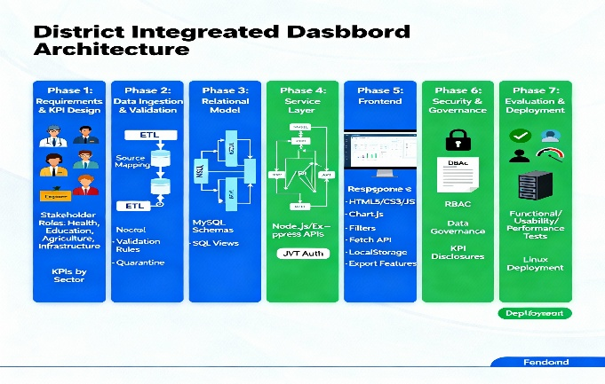

Fig-1
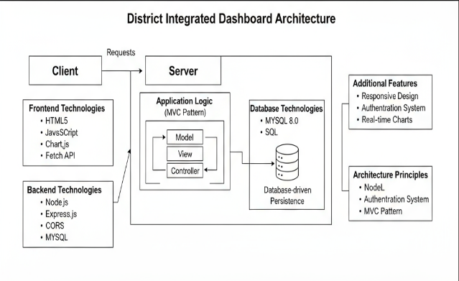
Fig-2(Architecture Diagram)
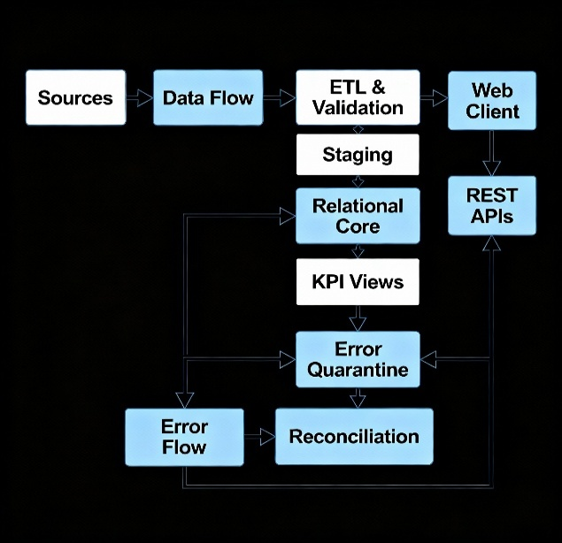
Fig-3(Dataflow Diagram)

A)Datasets used :
Education :
School facilities: school ID, taluk, electricity, computer lab count, library, playground, total teachers, total students; monthly/annual grain. Enables "Total Schools," facility distribution, teacher–student ratio, literacy trend.​Learning achievement (optional): assessment scores by grade/subject, attendance rate, dropout rate; term/annual gain.​
Health :
Service delivery: taluk, month, OPD patients, IPD patients, institutional deliveries, immunisation counts (BCG, DPT, etc.), blood banks, and emergency cases. Enables patient distribution, deliveries and vaccinations.​Hospital readiness: hospital ID, taluk, ICU beds, Oxygen points, Ambulance count, staff counts (doctors, nurses), equipment availability; quarterly grain.​
Agriculture :
Production: taluk, crop, season, area shown in HA, yield in MT, irrigation coverage PCT; seasonal grain. Triggers crop yield trend and irrigation coverage charts.
Sustainability: taluk, soil health index, registered farmers, annual grain.
Food processing and industry :
Industrial units: taluk, unit count, sector subtype, capacity in MT, employment total, employment women, export value INR; annual/quarterly grain. Supply industries count, employment, women's employment, and export performance.
Cross-cutting reference tables
Geography: district ID, taluk ID, names, parent relationships; canonical keys for joins.
Time dimension: month ID, quarter, year, start date, and end date for consistent aggregation.
Metadata/KPI dictionary: KPI ID, name, formula, numerator source, denominator source, unit, update frequency and owner for transparency and reuse.
Authentication and governance :
Users and roles: user ID, role (Admin/Officer/Analyst/Viewer), taluk scope, last login, audit trails for edits and publishes.
ETL logs: batch ID, source name, received at, processed at, rows total, rows loaded, rows quarantined, error reasons for data quality monitoring.
Data sources and formats :
Departmental CSV/Excel drops (monthly/quarterly), approved REST APIs, and legacy DB exports, mapped to canonical schemas with validation and staging before publishing to KPI views.
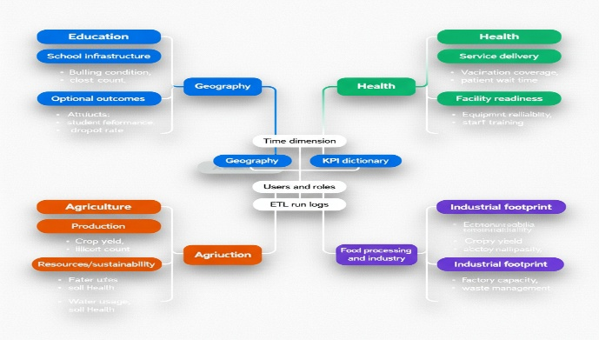
Fig-4(Dataset)
B)Types of models used :
Architectural models :
MVC pattern: Model (MySQL schemas and KPI views), View (HTML5/CSS3/JS + Chart.js), Controller (Node.js/Express routes). Client–server model: Browser client talks to REST APIs via HTTPS; APIs talk to the database and ETL.
Data and integration models :
Relational data model: Normalised schemas for Geography (district–taluk–block), Time, and Sector tables (Health, Education, Agriculture, Food Processing) with foreign keys and indexed KPI views.ETL/validation model: Staging → validation (type, range, referential, duplication) → quarantine with reason codes → curated production tables → KPI materialisation.Metadata/KPI dictionary model: Formal definitions including formula, unit, numerator/denominator, update frequency, and data owner for transparency.
Security and governance models :
RBAC model: Roles—Admin, Officer, Analyst, Viewer—with scoped permissions for edit, review, publish, and export; audit logs for all data‑changing actions.Data lineage and versioning pattern: Dataset versions, change logs, and rollback processes for reconciliation support and audits.

API and interoperability patterns :
RESTful resource pattern: Versioned endpoints by sector (e.g., /api/education/kpi, /api/health/kpi) with query parameters for period, taluk, block, and indicator; consistent response schema and error contracts.
Caching pattern: Pre‑aggregated SQL views and response caching for frequent queries to meet latency requirements.
Analytics and visualization patterns :
Comparative analytics pattern: Cross-taluk benchmarking, trend analysis, and composition views onto bar/line/donut charts with homogeneous color semantics and units.​
Alert/threshold pattern (optional): Rule-based KPI thresholds (e.g., beds per 10k, pupil–teacher ratio) with flags for manual review.​
Operational patterns :
Export pattern: Deterministic CSV/PNG exports with inlined metadata (date, source, filters) for meeting artifacts.​
Deployment pattern: Single-node Linux with reverse proxy and PM2 to start, extensible to multi-instance scaling; scheduled ETL jobs with freshness indicators.
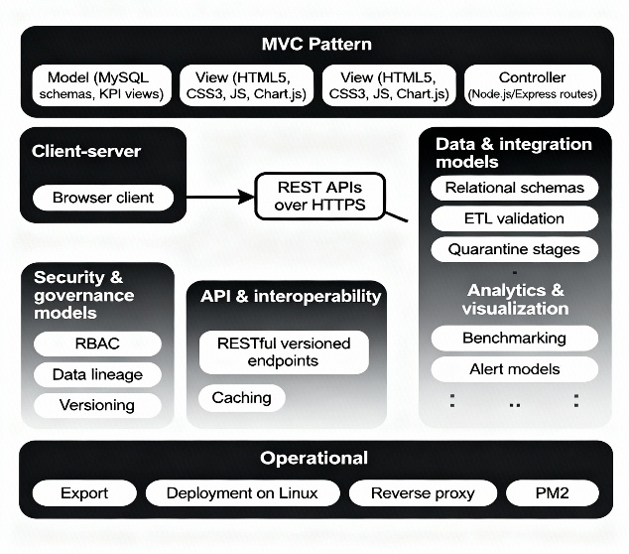
Fig-5(Types of models)
C)Performance matrices :
Data ingestion and quality :
ETL rate of success: ≥ 98% error-free rows loaded per batch.
Validation rejection rate: 0.5–3% rejected rows with reason codes (track by sector).
Data freshness lag: ≤ 24 hours from drop to availability on dashboard; priority KPIs ≤ 4 hours.
Reconciliation close time: ≤ 7 days to close quarantined records.
API and backend :
P95 API latency: ≤ 800 ms for KPI endpoints under normal load.
Error rate: ≤ 2 per 1,000 requests (5xx + validation 4xx).​
Read throughput: ≥ 50 requests/second sustained without degradation.​
Cache hit ratio: ≥ 70% for overview and common comparison queries.​
Database :
P95 query time (views): overview, taluk compare, 12‑month trend each ≤ 500 ms.​
Index utilization: ≥ 95% of targeted queries use intended indexes (via EXPLAIN).​
Storage growth: monthly delta monitored; alerts when > 20% month‑over‑month to invoke archiving.​
Frontend UX :
First contentful paint (dashboard): ≤ 1.8 s on mid‑range device/network.
Chart render after filter change: ≤ 1.0 s to paint updated visualization.
Export time: CSV/PNG generation ≤ 10 s for any dashboard section.
Reliability and security :
Uptime (APIs + DB): ≥ 99.5% monthly availability.
Auth anomaly rate: failed logins/total logins ≤ 5% (investigate spikes by role).
Audit coverage: 100% of data‑changing actions logged with user, timestamp, before/after.
Adoption and impact :
Monthly active users (by role): Admin, Officer, Analyst, Viewer; aim for steady growth 10–20% during first two review cycles.​
Session success rate: ≥ 75% of sessions have at least one KPI view and one export.​
Review prep time saved: ≥ 50% improvement over spreadsheet baseline by cycle 2.​
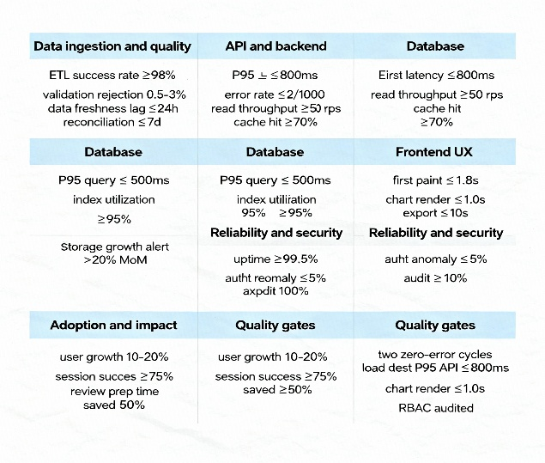
Fig-6(Performance Matrices)

IV. Results:
Cross-sector consolidation :
The template brings together four main sectors into a single setup. Education, Health, Agriculture and Food Processing all fit under one webpage interface. It includes sector tabs along with a taluk chooser. This approach checks the full cabling from raw data all the way to the final visualization.
Usability and navigation :
A top navigation bar shows up again on every page. KPI cards stay in view and filter dropdowns like “All Taluks” remain accessible no matter the section. That setup allows quick shifts between sectors and deeper dives into details. It keeps things from getting set on the page.​
KPI visibility :
Education: Shows the total number of Schools is 900, the total number of Computers is 348 and Libraries total 881.
Health: Total Patients 18,800; Hospitals 90; BCG Vaccinations 23,547; Medical Staff 1,520; Deliveries 2,256; Blood Banks 24.​
Agriculture: it covers things like crop yield and irrigation area. Soil health shows up too. Farmers and organic farming appear in editable cards. These cards confirm schema coverage for production metrics. They also handle irrigation and organic details.
Food Processing: Industries are 143. Employment stands at 8760. Export value and production capacity are displayed. Women’s employment hits 3062. All this validates the inclusion of the industry indicators.
Analytical charts :
Education: Features Bar charts for education by taluk. Teachers and Students ratio appears in those charts. A line chart tracks literacy advancement. This setup allows comparisons over time. Cross taluk views work well too.
Health: Bar and doughnut charts for institutional deliveries, patient distribution by taluk, emergency service, and medical equipment to support capacity and service mix.​
Agriculture: Crop yield trend bar chart and irrigation coverage pie chart, allowing seasonality and coverage to be assessed.​
Overview: District landing displays education bars and health donut, with KPI counters, proving the multi-sector summary screen.​
Data editing and roles :
Edit" buttons on KPI cards in all sectors and the availability of login and registration pages with role choice demonstrate role-based access and data management workflows for admins/officers and viewers, enhancing governance and data stewardship.
Consistency and responsiveness :
Consistent card shapes, padding, and Chart.js‑esque looks are all across screens; screenshots depict desktop views with legible typography and padding, implying responsive components that should render on smaller devices with few variations.​
Sector-specific insights demonstrated :
Education: Pie chart of visible facility distribution and infrastructure overview by taluk enable facility gap identification (e.g., labs vs libraries) at a glance.​
Health: Equipment chart (ICU beds, Oxygen) and emergency services donut enable assessment of preparedness across taluks.​
Agriculture: Crop yield and irrigation coverage visuals enable potential correlation identification between irrigation and yield by taluk.​
Food Processing: Employment generation bars and export performance pie provide instant views of industrial contribution and distribution by taluk.
Readiness for reviews :
The landing page KPI counters and sector dashboards offer an easily presentable package for district review meetings, eliminating manual spreadsheet compilation and facilitating evidence-based discussions with visual comparisons.​
Gaps and next steps :
Observed placeholder or extreme values (e.g., very large numbers in Agriculture and Export Value) indicate the requirement of number formatting, unit verification, and validation thresholds prior to use in production; including geospatial overlays and exports will enhance decision support further.

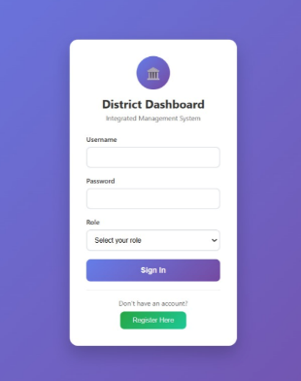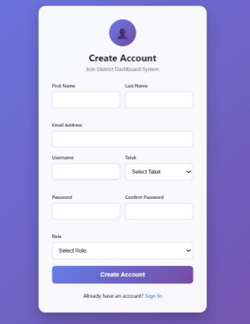
Fig-7(Login & Register Page)
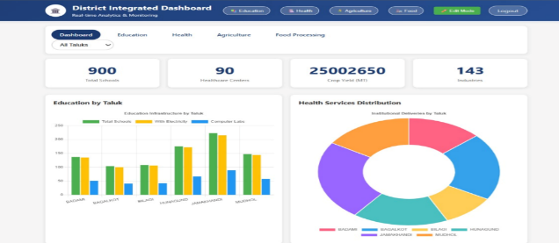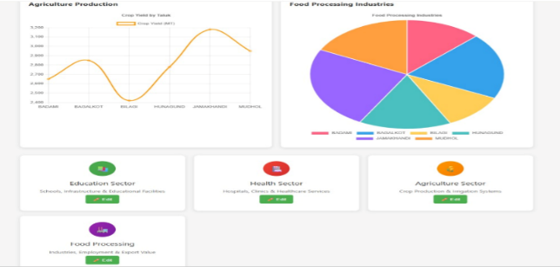
Fig-8(Overview of Dashboard)
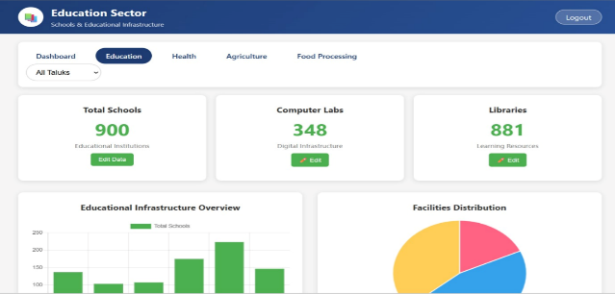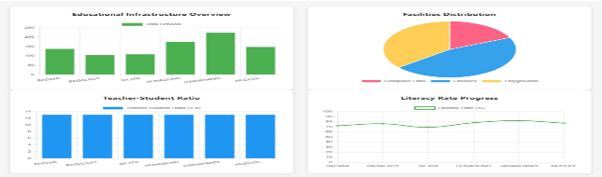
Fig-9(Education Dashboard)
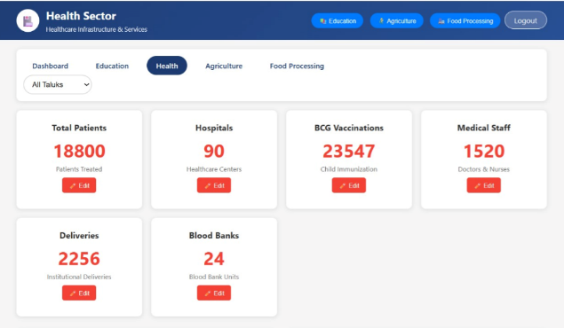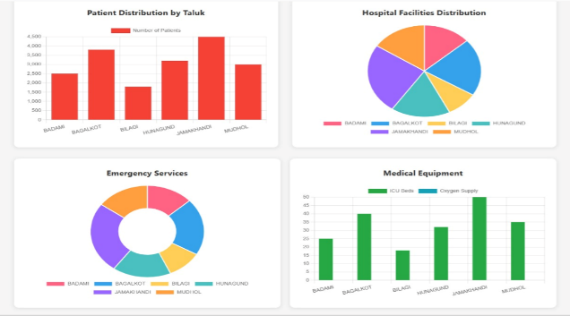
Fig-10(Health Dashboard)
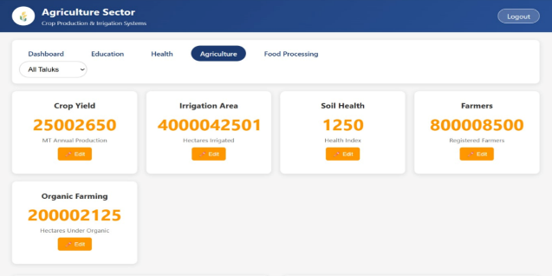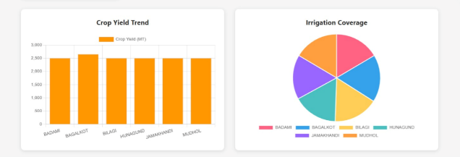
Fig-11(Agriculture Dashboard)
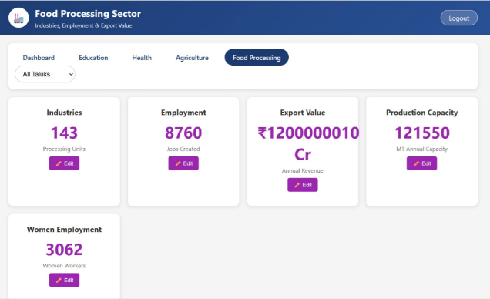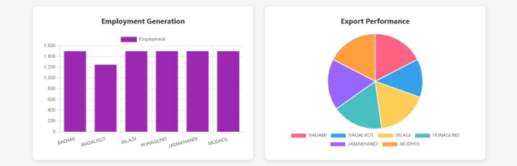
Fig-12(Food Processing Dashboard)

V)Conclusion :
District Integrated Dashboard demonstrates how a single, role‑aware web platform can consolidate multi‑sector KPIs at district, taluk, and block levels to replace disparate spreadsheets with homogeneous, decision‑ready views that accelerate monthly reviews and enhance accountability.​​
The layered architecture handles validated ETL processes that feed normalised MYSQL schemas. There is also a responsive client built with HTML5, CSS3 and JavaScript along with Chart.js integration.
Built in authentication keeps things secure from the start. RBAC controls access properly. Audit trails track every change.
Dashboards cover Education, Health, Agriculture and Food Processing sectors. They demonstrate instant utility right away. Gaps in facilities stand out clearly. Distribution of services shoes up well. Coverage of irrigation gets highlighted. Data freshness badges should be added before going live in production.
Timed ingestion supports the flow of data. The dashboard scales smoothly from Bagalkot level.

VI) Reference :
[1] A. P. Dameri, "Towards a Governance Dashboard for Smart Cities Initiatives: A System of Systems Approach," IEEE Systems of Systems Engineering (SoSE), 2020.
[2] J. D. Velázquez et al., "Cities-board: A Framework to Automate the Development of Smart Cities Dashboards," IEEE Internet of Things Journal, vol. 7, no. 9, pp. 8793–8805, 2020.
[3] C. Few and S. Edge, "What Do We Talk About When We Talk About Dashboards?," IEEE Transactions on Visualisation and Computer Graphics, vol. 25, no. 1, pp. 479–489, Jan. 2019.
[4] H. L. Truong et al., "Real-Time Data Visualisation Frameworks for Smart City Applications," Elsevier Future Generation Computer Systems, vol. 125, pp. 432–446, 2022.
[5] P. K. Paul et al., "Exploring Open Data Journey of Indian Smart Cities," IEEE Smart Cities Newsletter, 2021.
[6] A. R. Pradana et al., "Design of KPI Dashboard for Indonesian Higher Education," in Proc. IEEE Int. Conf. on Computing, Communication and Informatics (ICCIC), 2017, pp. 1–6.
[7] D. Misra and S. Sarkar, "A Hybrid and Distributed Architecture for an Interoperable E-Government Portal," in Proc. IEEE WICT, 2013, pp. 58–63.
[8] C. K. Hsu, "Governance to Service—Smart City Evaluations in Taiwan," Int. J. of Computer Science Studies (IJCSS), vol. 3, no. 4, pp. 56–64, 2011.
[9] R. Mora et al., "Geospatial Dashboards for Monitoring Smart City Performance," IEEE/MDPI Sensors, vol. 19, no. 23, p. 5185, Dec. 2019.
[10] S. Ray et al., "Interactive Dashboard for COVID-19 Monitoring in India," IEEE Access, vol. 9, pp. 125478–125490, 2021.
[11] National Health Mission (NHM) – HMIS Portal, Govt. of India. [Online]. Available: https://hmis.nhp.gov.in
[12] Unified District Information System for Education (UDISE+) – Govt. of India. [Online]. Available: https://udiseplus.gov.in
[13] Open Government Data (OGD) Platform India – Govt. of India. [Online]. Available: https://data.gov.in
[14] National Crime Records Bureau (NCRB) – Govt. of India. [Online]. Available: https://ncrb.gov.in
[15] Census of India – Office of the Registrar General & Census Commissioner. [Online]. Available: https://censusindia.gov.in
[16] The World Bank – World Development Indicators. [Online]. Available: https://data.worldbank.org
[17] NITI Aayog – Aspirational Districts Dashboard. [Online]. Available: https://dashboard.niti.gov.in
[18] S. Kumar et al., "Smart City Performance Indicators," in Proc. IEEE Int. Smart Cities Conf. (ISC2), 2019, pp. 293–298

